Assignment 3 (10%)

Run the script called CityJail_8 under Assignment 3 on e.Centennial. The script will create tables and also insert values in the table. Then you can do joins as in Assignment 3.

The following list reflects the current data requests from city managers. Provide the SQL statements that satisfy the requests. For each request, include one solution using the traditional method and one using an ANSI JOIN statement. Test the statements and show execution results. Copy the command and also the result after each question below:

1. List all criminals along with the crime charges filed. The report needs to include the criminal ID, name, crime code, and fine amount.

**Old Version:**

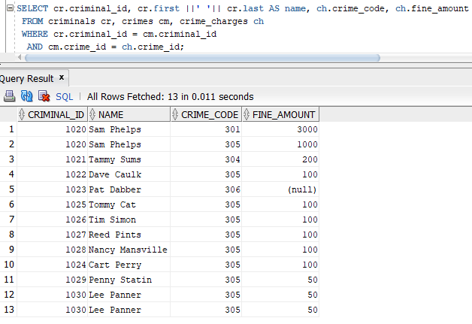

**New Version:**

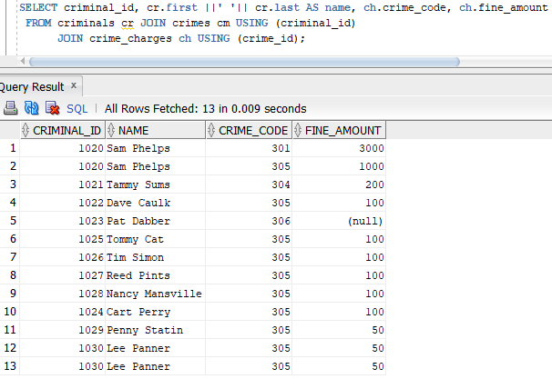

1. List all criminals along with crime status and appeal status (if applicable). The reports need to include the criminal ID, name, crime classification, date charged, appeal filing date, and appeal status. Show all criminals, regardless of whether they have filed an appeal.

**Old Version:**

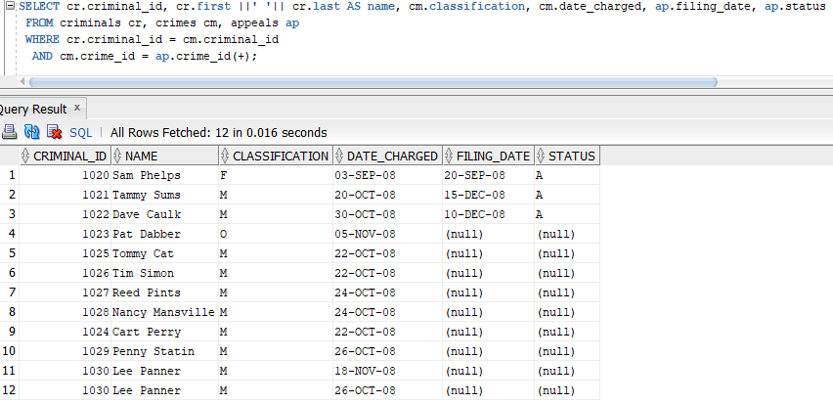

**New Version:**

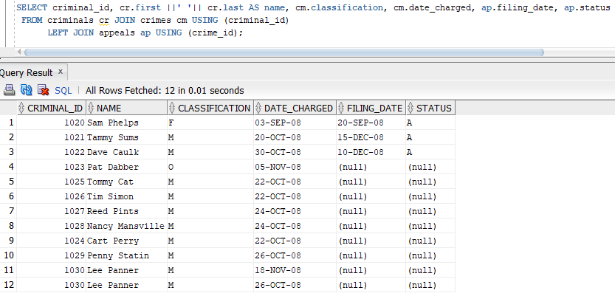

1. List all criminals along with crime information. The report needs to include the criminal ID, name, crime classification, date charged, crime code, and fine amount. Include only crimes classified as “Other.” Sort the list by criminal ID and date charged.

**Old Version:**

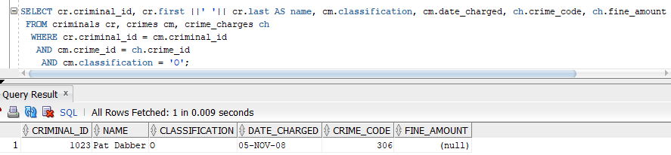

**New Version:**

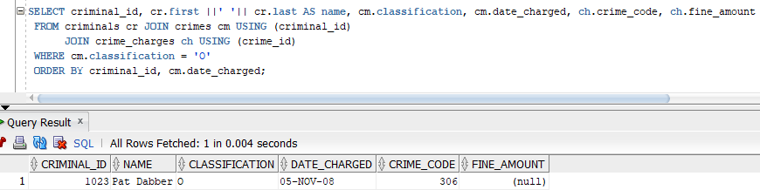

1. Create an alphabetical list of all criminals, including criminal ID, name, violent offender sta- tus, parole status, and any known aliases.

**Old Version:**

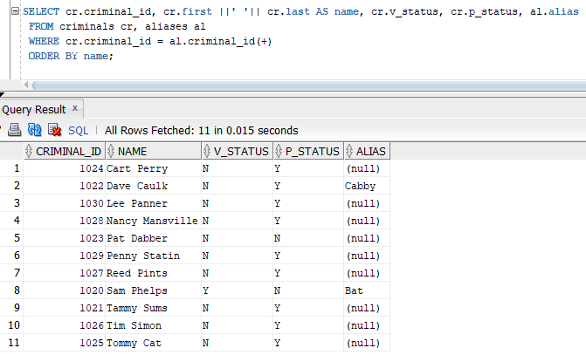

**New Version:**

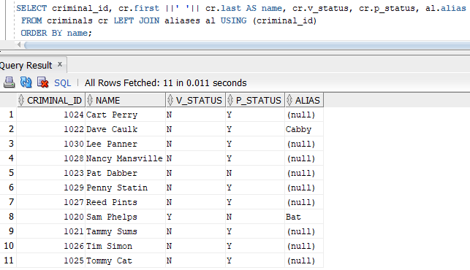

1. A table named Prob_Contact contains the required frequency of contact with a probation officer, based on the length of the probation period (the number of days assigned to probation). Review the data in this table, which indicates ranges for the number of days and applicable contact frequencies. Create a list containing each criminal who has been assigned  a probation period, which is indicated by the sentence type. The list should contain the crim- inal name, probation start date, probation end date, and required frequency of contact. Sort the list by criminal name and probation start date.

**Old Version:**

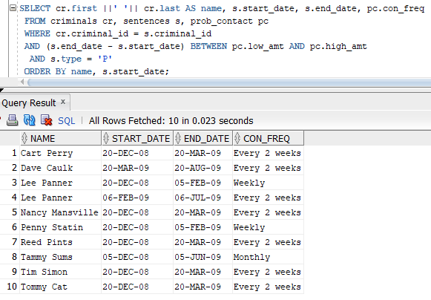

**New Version:**

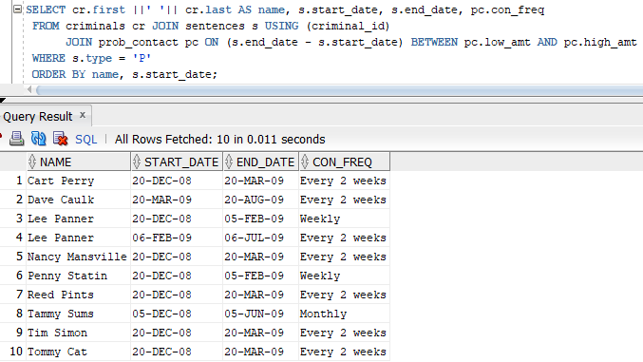

1. A column named Mgr_ID has been added to the Prob_Officers table and contains the ID number of the probation supervisor for each officer. Produce a list showing each probation officer‘s name and his or her supervisor‘s name. Sort the list alphabetically by probation offi- cer name.

**Old Version:**

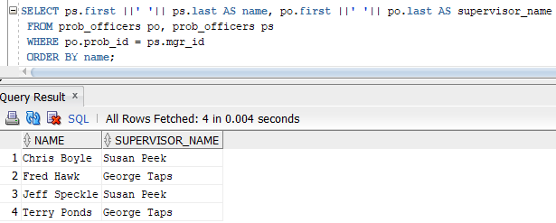

**New Version:**

